Agenda

*Date: 03/08/14*

*Location: Brody Collaborative Space - Room 1045 and 1042*

*Actual Time: 1pm - sometime*

*Planned Length: a while*

***Silly Picture of the Week:***

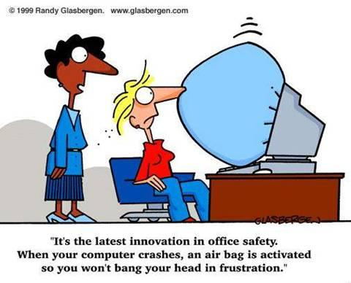

***Please add and comment on anything and everything in the agenda!***

|  |  |  |  |
| --- | --- | --- | --- |
| **Team Member(s)** | **Topic** | **Time** | **Goals** |
| Anyone | Announcements | 5 min | If any new developments have occurred the team is updated on them |
|  |  |  |  |
| Everyone | Presentation Slides |  | People write their presentation slides so that all slides are drafted |
| Mark | Results Pages Amazingness |  | Consult with backend to make an awesome results page of awesomeness |
| David and Brian | Strabismus | 30 min | Look up standard criteria for diagnosing strabismus. Figure some way to get a good threshold in the code |
| Shumin, Shannon, and Brian | Improve Pupil detection |  | Look over code for pupil detection and possibly look over JT’s proposed revisions from last quarter. Tweak variables of figure out how to get variables to tweak themselves for greater accuracy |
| Arvind and Andrew | Hardware | a while | Build bracket to get working prototype |
| Front End | Moar pages |  | Do more pages! |
| Xiaomeng, Brian, and Si | Fix Bugs |  | All bugs found in code from testing are fixed. Maybe consult with Shannon if you’re at a sticking point |
| Shannon | Recap, Next steps and Weekly Deliverables | 10 min. | Meeting progress/ goal accomplishment is recapped. Next steps are outlined so that every team member goes into next week knowing what they are expected to contribute. |

# Notes

# Summary

# Whiteboard Pics

# Useful Links

Front-End Frame Documentation: <http://docs.wxwidgets.org/2.8.11/wx_wxframe.html#wxframe>

Dropbox: <https://www.dropbox.com/sh/8nsmamaiklpvr9l/Fo5xgv4ogH>

Front-End Code for User Drawing <https://groups.google.com/forum/#!topic/wxpython-users/cDqEj_pTnjs>

<https://web.archive.org/web/20130705022341/http://www.adaptive-vision.com/en/technical_data/documentation/3.0/filters/FeatureDetection/cvHoughCircles.html>